DOCUMENT IDENTIFIER: |  | TR MDD500/241238
SUBJECT: | GVDM-MLT SYSTEM MANUAL

CONTRACT: | N/A
CDRL: | N/A

This document contains proprietary information on Israel Aerospace Industries Ltd. It may not be reproduced, copied, disclosed, or utilized in any way, in whole or in part, without the prior written consent of Israel Aerospace Industries Ltd.

Revision Status

Rev | Number of Pages | Description of Change | Author | Revision Date
- | 34 | First Release | Michael Jack | 09.01.2025

Table of Contents
1 GVDM SYSTEM MANUAL 4
1.1 System Overview 4
1.2 System Architecture 5
1.3 Operational Phases 7
1.4 Network Interface Cards Configuration 8
1.5 Configuration Management 9
1.6 Configuration File 9
1.7 Configuration File Parameters 10
1.8 Configuration File Sample 13
1.9 Logging 15
1.9.1 Key Features of the Logging Mechanism 15
1.9.2 Execution Log Details 16
1.9.3 Metrics Log Details 16
1.10 Message Types 17
1.11 Message Handlers 17
1.12 Command Messages: AGCS to GVDM 18
1.13 Command Message: GVDM to IVDM 19
1.14 Report Messages: GVDM to AGCS 19
1.15 Data Messages: AGCS to GVDM 21
1.16 Data Messages: IVDM to GVDM 27
2 Performance requirements 29
3 message routing table 30
4 sequence diagram 31
5 GVDM.exe Metadata 32
6 Glossary of Acronyms 33
7 summary 34

GVDM SYSTEM MANUAL

System Overview
The Ground Video-Data Multiplexer (GVDM) is a sophisticated system that enables bidirectional Ethernet communication between the Ground Control Station (AGCS) and the Interface Video-Data Multiplexer (IVDM), utilizing two Network Interface Cards (NICs).
The GVDM real-time software component plays a crucial role in enabling the communication. Operating from a dedicated computer, the GVDM software efficiently and effectively manages various message types, including commands, reports, and, most importantly, data exchanged between the AGCS and the IVDM. It acts as a mediator between two distinct communicating entities on two networks.
The GVDM software application is not a mere passive receiver and transmitter of messages. It is a dynamic and intelligent system that actively responds to three command messages issued by the AGCS, directing its operations. In turn, it provides feedback to the AGCS through two report messages. What truly sets the GVDM apart is its intelligent and proactive management of message routing configurations. These configurations are not fixed but can be adjusted based on initial one-time input from a predefined system configuration file and command messages.
With its robust functionality, the application controls and routes six data messages between AGCS and IVDM using the User Datagram Protocol (UDP) and serial communication. It relays three data messages from AGCS to IVDM and three from IVDM to AGCS.
The GVDM application is designed with scalability in mind, supporting communications with up to twenty-four AGCS computers. This ability to flex and adjust makes the GVDM a robust and reliable choice for managing large-scale operations.
Its adaptability and reliability instill confidence in its capabilities and assure its ability to handle efficient message routing needs.

System Architecture
The GVDM software application's architecture is designed to be multithreaded, leveraging eight concurrently executing threads to ensure simultaneous and highly efficient message processing. This system integrates several vital components, each playing a crucial role in the overall functioning of the GVDM, a detailed understanding of which enhances interaction with the software.
- Configuration Management configures the application’s interfaces and operational mode.
- Performance Optimization allocates eight dedicated CPU cores to eight concurrently executing threads and sets three time-critical threads to run with real-time priority.
- UDP Servers and Clients receive and send UDP packets concurrently across two networks, supporting multiple IP addresses and ports. The application leverages Boost ASIO for its asynchronous I/O capabilities, enhancing UDP communications.
- Pcap Sniffer intercepts network packets that meet specific source and destination IP address criteria using the Npcap packet capture library toolkit.
- Serial Communication manages the reception of one specific message type via a serial communication protocol.
- Message Processing handles command, data, and report messages based on predefined rules. Each message has unique routing requirements. Some data messages undergo unique data manipulation.
- Multithreading handles multiple concurrent tasks, such as listening for incoming messages, processing messages, and sending outgoing messages in both directions, AGCS to IVDM and IVDM to AGCS. All messages are processed concurrently on a first-come, first-served basis. Both command and data messages are processed immediately upon receipt without queuing or prioritization, and no messages are buffered.
- Synchronization mechanism manages shared real-time data propagation across distinct threads, ensuring thread safety and consistent data access. It facilitates inter-thread communication and employs synchronization mechanisms like mutexes to prevent race conditions and data corruption.
- Logging and Diagnostics, a vital function, logs critical events, performance metrics, and errors at predefined severity levels. This comprehensive tracking system supports debugging, performance monitoring during development, health monitoring, and operational status tracking in production mode.
- Error Handling mechanisms are designed to address unexpected situations such as lost network connections or corrupted data. The application diligently attempts recovery in network failure, message loss, or invalid command messages. If recovery fails, the system may terminate, ensuring its integrity.
- Checksum is a unique identifier consisting of eight hexadecimal numbers that act as a fingerprint for application source code against which later comparisons can be made to detect changes in the application’s source code. The checksum is essential because it checks files for integrity and verifies that the same application is deployed across workstations.
- Metadata is information about the application, such as product name, file description, file version, and product version, i.e. checksum. All this information appears in the GVDM.exe file’s Properties dialogue under the Details tab.
- Security: No encryption or authentication mechanisms exist for communications between AGCS, GVDM, and IVDM.
- Redundancy and Failure Recovery: No built-in redundancy or failure recovery mechanisms exist. In the event of a failure or crash, the GVDM requires manual recovery.

Operational Phases
- Initialization: The GVDM configures NIC IP addresses from an external configuration text file. This is a one-time operation performed solely at the application startup.
- Maintenance: At application startup, GVDM executes a PowerShell script to manage old execution logs in the logs folder, preventing the uncontrolled accumulation of stale logs. This operation is performed once per startup. The script utilizes the metadata of log files to determine their creation timestamps. It then deletes all but the most recent twenty logs, ensuring that only the last ten execution trace logs and the last ten execution metrics logs are preserved, as two logs are generated per execution (one for execution trace and one for execution metrics).
- Idle: Following initialization and maintenance, the GVDM transitions to an operational state. It concurrently listens for incoming messages on both NICs across multiple ports. It can receive command messages from AGCS and data from AGCS and IVDM.
- Command Processing: Upon receiving a command message from AGCS, the GVDM processes the command and executes actions based on its opcode. Subsequently, it generates and dispatches report messages back to AGCS in response to the commands received.
- Data Processing: Individual data messages are processed according to predefined rules and routed to their designated destinations. The specific actions depend on the message type and its origin and destination. After processing, the GVDM awaits the following message, and so on.
- Termination: Upon manual termination via closing the console of the executing application, an execution log is saved in the ‘logs’ directory next to the GVDM application’s executable file for later use if needed.

Network Interface Cards Configuration
The computer on which the GVDM application executes is equipped with two Network Interface Cards (NICs), pivotal components of the data message routing process between AGCS and IVDM. At the start of the application, the GVDM meticulously reads the predefined IP addresses for both NICs from an external configuration file.
Before executing the GVDM application, it is essential to configure the IP addresses for the NICs manually. This configuration must be done at least once during the initial computer setup and preparation and as needed if the IP addresses of the GVDM NICs need to change.
The required configuration can be done through the user interface of the operating system network connections on the computer where the GVDM application is running. The IP addresses configured in the operating system must precisely match those specified in the configuration file. It is worth noting that the data in the configuration file remains intact even after the GVDM application is shut down.
The AGCS NIC is configured to communicate with the AGCS using four fixed IP addresses: 91.100.8.30 with a subnet mask of 255.255.0.0, 93.100.1.67 with a subnet mask 255.255.0.0, 91.100.6.5 with a subnet mask 255.255.255.0 and 91.100.8.2 with a subnet mask 255.255.0.0.
The IVDM NIC is configured to communicate with the IVDM using a variable IP address, e.g., 222.109.81.64, with a subnet mask 255.255.255.0.
Any changes to the system’s NIC IP addresses require updating the configuration file to ensure consistent connectivity and functionality.

Configuration Management
The application starts by configuring network interfaces. The application's network interface configuration setup is automated, aligning with specific networking requirements (such as utilizing a particular NIC based on its IP address). The application first ensures the IP configuration settings are synchronized with system settings, and once validated, the application retrieves the respective NIC’s Network Packet Filter (NPF) device number. It updates the external JSON configuration file with the system data retrieved. This automation enhances the application's usability, robustness, ease of operation, and user-friendliness, reducing manual configuration steps and potential user error. The application then continues by reading system configurations from the updated file. It uses the obtained data to configure IP addresses and port numbers of listening and sending UDP servers, a serial communication line, logger level, operation, and log maintenance. This is a one-time operation that happens at the start of application execution.

Configuration File
The configuration file is part of the GVDM application installation. It is crucial for setting up and managing the communication parameters required by the GVDM application to enable bi-directional communication between the Ground Control Station (AGCS) and the Interface Video-Data Multiplexer (IVDM).
While this documentation is indispensable as a vital external reference for system developers, who must utilize it to ensure the configuration settings are correctly applied, facilitating efficient and precise data communication and system operation, the configuration file does NOT need to be touched by system users. It is discussed here for informative purposes.
Since the agcs_nic_device parameter, which is required for the Pcap sniffer, is unique to each NIC, the GVDM application automatically retrieves its value from the computer’s NIC at the start of each execution and updates the configuration file by filling it out in the appropriate fields.
The ONLY parameter the system user must configure manually is the ivdm_nic_ip, which must match the user-chosen IP address for the IVDM NIC. Its assigned value must be consistent in the configuration file's seven occurrences of this parameter.

Configuration File Parameters
The GVDM system configuration file (gvdm_config.json) is structured in JSON format, with different sections dedicated to various components and functionalities of the GVDM system. Each section contains key-value pairs that configure specific aspects of the network communication and operational settings.
1. GVDMCommand
- agcs_nic_ip: IP address where the AGCS NIC listens for incoming packets.
- agcs_nic_lst_port: Port on which the AGCS NIC listens for incoming packets.
- agcs_dst_port: Destination port for sending packets to the AGCS.
- ivdm_dst_port: Destination port for sending packets to the IVDM.
- ivdm_nic_ip: Source IP address for packets sent from the IVDM NIC.
2. EUCommand
- agcs_nic_ip: IP address where the AGCS NIC listens for incoming packets.
- agcs_nic_lst_port: Port on which the AGCS NIC listens for incoming packets.
- agcs_nic_device: Device identifier for the AGCS NIC, used for network packet filtering.
- agcs_nic_pcap_filter: Pcap packet capture filter for identifying relevant network traffic specific to the particular message traffic.
- ivdm_dst_port: Destination port for sending packets to the IVDM.
- ivdm_nic_ip: Source IP address for packets sent from the IVDM NIC.
3. UplMission
- agcs_nic_device: Device identifier for the AGCS NIC, used for network packet filtering.
- agcs_nic_pcap_filter: Pcap packet capture filter for identifying relevant network traffic specific to the particular message traffic.
- ivdm_dst_port: Destination port for sending packets to the IVDM.
- ivdm_nic_ip: Source IP address for packets sent from the IVDM NIC.
4. UplTelemetry
- agcs_nic_ip: IP address where the AGCS NIC listens for incoming packets.
- agcs_nic_lst_port: Port on which the AGCS NIC listens for incoming packets.
- serial_port: Designated serial port for receiving serial data.
- baud_rate: Communication speed for the serial connection.
- ivdm_dst_port: Destination port for sending packets to the IVDM.
- ivdm_nic_ip: Source IP address for packets sent from the IVDM NIC.
5. IVDMStatus
- ivdm_nic_ip: IP address where the IVDM NIC listens for incoming packets.
- ivdm_nic_lst_port: Listening port on the IVDM NIC for IVDM status messages.
- agcs_dst_ip: Destination IP address for sending packets to the AGCS.
- agcs_dst_port: Destination port for sending packets to the AGCS.
- agcs_nic_ip: Source IP address for packets sent from the AGCS NIC.
- agcs_nic_src_port: Source port for packets sent from the AGCS NIC.
6. EUStatus
- ivdm_nic_ip: IP address where the IVDM NIC listens for incoming packets.
- ivdm_nic_lst_port: Port on which the IVDM NIC listens for incoming packets.
- agcs_dst_ip: Destination IP address for sending packets to the AGCS.
- agcs_dst_port: Destination port for sending packets to the AGCS.
- agcs_nic_ip: Source IP address for packets sent from the AGCS NIC.
- agcs_nic_src_port: Source port for packets sent from the AGCS NIC.
7. DnlMission
- ivdm_nic_ip: IP address where the IVDM NIC listens for incoming packets.
- ivdm_nic_lst_port: Port on which the IVDM NIC listens for incoming packets.
- agcs_nic_ip: Source IP address for packets sent from the AGCS NIC.
8. PowerShell Script
- Script name for logs file management administrative task.
9. Logger
- sink_type: Determines the output destinations for logging messages the application generates. This configuration is essential for routing log data according to the operational needs and debugging preferences.
  - console_sink: Prints log messages solely to the system's console. It is helpful for real-time monitoring when the application is actively monitored.
  - file_sink: Prints log messages solely to a file on the system. This option is valuable for preserving log data for later review and analysis.
  - console_file_sink: Prints log messages to the console and a file, ensuring immediate visibility and persistent log data storage. (Default)
- logging_level: Specifies the minimum severity level of events the logger will capture and record. Adjusting this parameter helps filter out less critical messages and focus on the more significant events, which is essential for effective system monitoring.
  - 0 (trace): Captures all verbose messages, typically used for detailed debugging.
  - 1 (debug): Includes detailed information often helpful in diagnosing problems.
  - 2 (info): Provides informational messages highlighting the application's progress. (Default)
  - 3 (warn): Indicates potentially harmful situations that are not necessarily errors.
  - 4 (err): Records error events of considerable importance that will hinder normal operations.
  - 5 (critical): Captures severe error events that might cause the application to abort.
  - 6 (off): Turns off logging entirely, ensuring no events are logged.
- execution_duration_minutes: Defines the duration for which the application will be active. A value of 0 or less indicates that the application should execute indefinitely until it is shut down externally. Any positive integer specifies the number of minutes the application will run before automatically shutting down.

Configuration File Sample
Below is the content of the gvdm_config.json configuration file with actual values used during GVDM system development for reference and better understanding. Please note that each NPF number is unique to each NIC and will differ on each computer.
{
"GVDMCommand": {
"agcs_nic_ip": "91.100.8.30",
"agcs_nic_lst_port": 110,
"agcs_dst_port": 110,
"ivdm_dst_port": 7002,
"ivdm_nic_ip": "222.109.81.64"
},
"EUCommand": {
"agcs_nic_ip": "93.100.1.67",
"agcs_nic_lst_port": 15001,
"agcs_nic_device": "\\Device\\NPF_{CFA90967-1FAF-43EC-91D4 2B0730A704B3}",
"agcs_nic_pcap_filter": "udp and dst host 93.100.1.67 and dst port 15001",
"ivdm_dst_port": 4102,
"ivdm_nic_ip": "222.109.81.64"
},
"UplMission": {
"agcs_nic_device": "\\Device\\NPF_{CFA90967-1FAF-43EC-91D4-2B0730A704B3}",
"agcs_nic_pcap_filter": "udp and not dst port 110 and not dst port 5007 and not (dst host 93.100.1.67 and dst port 15001)",
"ivdm_dst_port": 4101,
"ivdm_nic_ip": "222.109.81.64"
},
"UplTelemetry": {
"agcs_nic_ip": "91.100.8.30",
"agcs_nic_lst_port": 5007,
"serial_port": "COM1",
"baud_rate": 38400,
"ivdm_dst_port": 4100,
"ivdm_nic_ip": "222.109.81.64"
},
"IVDMStatus": {
"ivdm_nic_ip": "222.109.81.64",
"ivdm_nic_lst_port": 4113,
"agcs_dst_ip": "226.1.2.100",
"agcs_dst_port": 4103,
"agcs_nic_ip": "91.100.8.30",
"agcs_nic_src_port": 5070
},
"EUStatus": {
"ivdm_nic_ip": "222.109.81.64",
"ivdm_nic_lst_port": 4110,
"agcs_dst_ip": "226.1.2.100",
"agcs_dst_port": 15002,
"agcs_nic_ip": "91.100.8.30",
"agcs_nic_src_port": 5080
},
"DnlMission": {
"ivdm_nic_ip": "222.109.81.64",
"ivdm_nic_lst_port": 4112,
"agcs_nic_ip": "91.100.8.30"
},
"PowerShellScript": {
"keep_last_ten_logs": "remove_gvdm_log_files_other_than_last_ten_logs.ps1"
},
"Logger": {
"sink_type": "console_file_sink",
"logging_level": 1,
"execution_duration_minutes": 0
}
}
Note that the value of the agcs_nic_device parameter, which is required for the Pcap sniffer, is unique to each NIC. The value of the ivdm_nic_ip parameter is set by the end-user during the IP address configuration of IVDM NIC. The GVDM application automatically retrieves both values from the computer’s IVDM NIC when the application starts and updates the configuration file by filling out the appropriate fields.

Logging
The GVDM application is designed to log errors and track execution metrics efficiently. Each time the application is executed, it generates two log files and saves them in the logs folder next to the application executable (GVDM.exe). These log files are named with a timestamp indicating the execution start time, ensuring clear identification of individual runs.

Key Features of the Logging Mechanism
- Log Naming: Log files include a timestamp in their title indicating the application’s execution start time:
  - gvdm_trace_log_date_time.txt
  - gvdm_metrics_log_date_time.txt
- Log Content:
- The execution log captures startup and runtime errors, providing insights into the application's operation. Depending on the logging_level defined in the gvdm_config.json configuration file, it can also help diagnose issues, including crash causes.
- The metrics log records execution metrics, updated periodically during runtime.
- This structured and configurable logging mechanism ensures that critical runtime and performance data are consistently captured, enabling effective monitoring, troubleshooting, and diagnosis of the GVDM application.

Execution Log Details
Usually, when the application executes in the background mode and is terminated externally, these metrics are not preserved in the execution trace log. They are stored exclusively in the execution metrics log. However, if the application executes in the application mode and is closed manually via the console window (e.g., by clicking the "X"), the most recent execution metrics are collected and appended to the associated execution trace log file. A typical execution trace log entry (without the optional execution metrics) appears as follows:
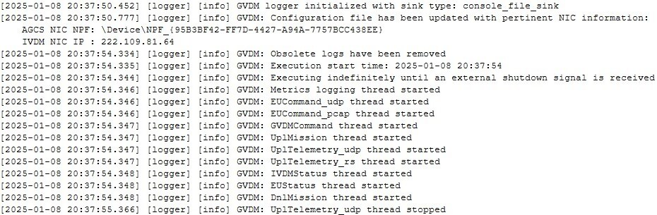

Metrics Log Details
The execution metrics log is updated every ten seconds and overwrites previous data with the latest snapshot. This ensures that only the most recent application execution metrics are preserved. A typical execution metrics log entry appears as follows:
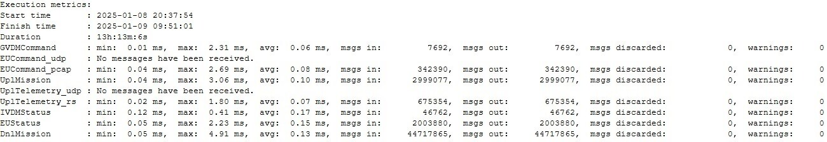

Message Types
The GVDM's message handling is a complex process involving receiving, processing, and relaying various messages. These include command messages from AGCS to GVDM, a command message from GVDM to IVDM, report messages from GVDM to AGCS, and data messages between AGCS and IVDM. Each message serves a specific purpose in the system's operation and requires dedicated handling.

Message Handlers
Separate individual handlers are custom-implemented for different messages (e.g., command messages from AGCS, report messages to AGCS, data messages to and from AGCS, a command message to IVDM, and data messages to and from IVDM). These handlers are responsible for parsing, validating, and processing the message contents.
- Command and Report Messages: These are relayed between AGCS and GVDM and govern the GVDM's operation.

- Command Message from GVDM to IVDM: This message seizes or relinquishes control of an IVDM.

- Data Messages: These are relayed between AGCS and IVDM, with the GVDM routing data messages from AGCS to IVDM and IVDM to AGCS based on the predefined rules.

Command Messages: AGCS to GVDM
The GVDM receives three command messages from AGCS via the AGCS NIC on port 110. They are identified and handled based on their operational codes (opcodes), housed in bytes 7-8 (in little-endian order) of the message payload. The command messages below are defined in the order of their handling priority.
- GVDM_set_gvdm_master_cmd
This command message instructs the GVDM which IVDM it needs to control or release from duty. Its payload size is either 24 or 25 bytes. Its opcode is 8, housed in bytes 7-8 (in little-endian order) of the message payload. In bytes 19, 20, 21, and 22, it stores either a valid IP address of an IVDM that the GVDM must take control of or 0.0.0.0, which orders the GVDM to release the controlled IVDM.

- GVDM_ip_source_cmd_masad
This command message contains twenty-four 8-byte slots that store up to twenty-four permitted IP addresses and priority and bandwidth parameters for each IP address. Its payload size is 250 bytes. It has an opcode of 13 housed in bytes 7-8 (in little-endian order) of the message payload. Starting from byte 23, twenty-four 8-byte slots store up to twenty-four permitted IP addresses, along with priority and bandwidth parameters for each IP address in the following fashion:
8-byte slot
BYTE | gvdm_table_index_0_cmd
BYTE | gvdm_ip_address_0_byte_1_cmd
BYTE | gvdm_ip_address_0_byte_2_cmd
BYTE | gvdm_ip_address_0_byte_3_cmd
BYTE | gvdm_ip_address_0_byte_4_cmd
BYTE | gvdm_priority_0_cmd
2_ BYTES | gvdm_max_rate_0_cmd
- GVDM_status_request_cmd
This command message requests the GVDM's status. Its payload size is either 20 or 22 bytes. Its opcode is 4, housed in bytes 7-8 (in little-endian order) of the message payload.

Command Message: GVDM to IVDM
- IVDMCommand
This command message seizes or relinquishes control of an IVDM. The GVDM creates and dispatches it either to the IVDM it wishes to take control of or to the controlled IVDM to port 7002. The message payload size is 8 bytes.

Report Messages: GVDM to AGCS
The GVDM sends two report messages to the AGCS via the AGCS NIC to port 110. They are identified and handled based on their operational codes (opcodes), housed in bytes 7-8 (in little-endian order) of the message payload.
- GVDM_host_ip_table_rpt_masad
This report contains the IP addresses and bandwidth values from the internal IP/bandwidth registration table. Its payload size is 220 bytes. Its opcode is 12, housed in bytes 7-8 (in little-endian order) of the message payload.

- GVDM_host_status_rpt_masad
This report provides the GVDM's operational status, which has yet to be determined. Its payload size is 85 bytes. Its opcode is 11, housed in bytes 7-8 (in little-endian order) of the message payload.
Upon receiving the GVDM_ip_source_cmd_masad message, the GVDM extracts all twenty-four IP addresses from it along with the associated bandwidth parameter and updates the IP/bandwidth registration table. Then, the GVDM composes the GVDM_host_ip_table_rpt_masad message, fills it out with the IP addresses and bandwidth values from the IP/bandwidth registration table, and sends it to the AGCS to the sender's IP address to port 110 from the source port 110, that is, to the source IP address obtained from the GVDM_ip_source_cmd_masad message IP header.
Upon receiving the GVDM_status_request_cmd message, the GVDM responds to the AGCS with the GVDM_host_status_rpt_masad message once every second to the sender's IP address to port 110 from source port 110. That is, to the source IP address obtained from the GVDM_ip_source_cmd_masad message IP header. It continues sending the GVDM_host_status_rpt_masad message until the GVDM is powered down. Since the GVDM_status_request_cmd message may be received numerous times throughout the application lifetime and from various sources, it is imperative to examine every GVDM_status_request_cmd message since it contains in its IP header the sender's IP address of the computer requesting the status update from the GVDM. Hence, the destination IP address of the GVDM_host_status_rpt_masad must be updated accordingly.

Data Messages: AGCS to GVDM
The GVDM is designed to receive three types of data messages from multiple AGCS computers via the AGCS NIC and route them to the controlled IVDM via the IVDM NIC. The key stipulation is that only the controlled IVDM can receive these UDP data messages from the AGCS via the GVDM.
- EUCommand

Identification
The destination IP is 93.100.1.67 in the message’s IP header or port 15001 in the message’s UDP header. Its payload size is 200 bytes.

Action
1. Extract the 20-byte IP and 8-byte UDP headers from the incoming message packet.
2. Add these extracted headers to the beginning of the outgoing message's payload, constituting the first 28 bytes. This step ensures that the outgoing message's payload incorporates the incoming message’s IP and UDP headers, which add up to 28 bytes. Consequently, the outgoing message's final payload size will be augmented by 28 bytes and be exactly 228 bytes.
3. Unicast the restructured message via IVDM NIC to the IP address of the controlled IVDM on port 4102.

- UplTelemetry

Identification
This message can be received either via Ethernet or serial communication, but not from both during a single program execution. Once the first message is received through one communication channel, the other channel is permanently turned off for that program execution since no messages will arrive via it.

Ethernet | Serial
Interface: AGCS NIC  Configured IP: Configured  Target Port: 5007  Message Type: Unicast  Message Size: 121 bytes | Serial Port: Configured, i.e., COM1  Baud Rate: 38,400  Parity: No parity  Stop Bit: 1  Message Size: 121 bytes  Period: 70 milliseconds  Sync byte 0: B0 (Hex)  Sync byte 1: B0 (Hex)  Sync byte 2: 3B (Hex)

Action
1. Construct a 16-byte long predefined header. The header data shall be stored in the big-endian format before transmission. Except for the gcs_eu_counter_cmd element, which is incremented by 1 with every transmitted message, the rest of the header data contain static information that does not vary between messages and is independent of the message payload. The header comprises the following elements:

uint32 gcs_eu_magic_word_cmd = 2957970420
uint16 gcs_eu_opcode_cmd = 6
uint16 gcs_eu_length_cmd = 200
uint16 gcs_eu_destination_cmd = 0
uint16 gcs_eu_source_cmd = 0
uint32 gcs_eu_counter_cmd = 0

2. Append the message payload to the aforementioned predefined header.
3. Increase the message payload's size to 200 bytes by padding it with zero bytes.
4. Compute a checksum for the first 198 bytes of the message. This checksum is the sum of all these bytes.
5. Encode the checksum in the message's final two bytes using big-endian format. Precisely, place the higher-order byte of the checksum in the 199th byte and the lower-order byte in the 200th byte of the message. In array notation, these are indices 198 and 199, respectively.
6. Unicast the complete message (200 bytes, including the checksum) via the IVDM NIC to the IP address of the controlled IVDM on port 4100.

- UplMission

Identification
Match between the message’s source IP address extracted from its IP header with an IP address in the internal IP/bandwidth registration table. This table is initially populated with IP addresses and bandwidth values extracted from the GVDM_ip_source_cmd_masad message. Upon receipt, extract the source IP address from the message’s IP header and juxtapose it against all valid IP/bandwidth registration table entries. If a match is found, proceed to action. If not, discard the message.

Action
1. Check the value of the matching bandwidth entry in the internal IP/bandwidth registration table.
2. Only proceed with further processing if the value of this bandwidth entry is non-zero.
3. Examine the payload size of the message:

- If it exceeds 360 bytes, discard the message.
- If it is less than or equal to 360 bytes, pad the message payload to 360 bytes by appending zeros, if necessary.

4. Extract the 20-byte IP and 8-byte UDP headers from the original message.
5. Add these extracted headers to the beginning of the new message's payload, making them the first 28 bytes. This inclusion means the new message's payload will incorporate the original message’s IP and UDP headers, totaling 28 bytes. This adjustment brings the new message's final payload size to 388 bytes.
6. Unicast the message via the IVDM NIC to the IP address of the controlled IVDM on port 4101.
To route data messages from the AGCS received via the AGCS NIC to a controlled IVDM via the IVDM NIC, the GVDM needs to initially receive the GVDM_set_gvdm_master_cmd message from the AGCS via the AGCS NIC on port 110. This message instructs the GVDM which IVDM it needs to assume control of.
Upon receipt of the GVDM_set_gvdm_master_cmd message, there are three potential scenarios.
- Scenario 1: The GVDM does not control any IVDM
If the GVDM does not control any IVDM, the AGCS may instruct the GVDM to assume control of a specific IVDM. To achieve this, the GVDM records the IP address of the IVDM it takes control of within the first four payload bytes and its own IP address in the last four payload bytes of the IVDMCommand message.

- Scenario 2: The GVDM controls an IVDM
If the GVDM controls an IVDM, the AGCS may instruct the GVDM to relinquish control of the controlled IVDM. To do this, the GVDM records the IP address 0.0.0.0 in the first four payload bytes and its own IP address in the last four payload bytes of the IVDMCommand message and sends it to the controlled IVDM to port 7002. Once the GVDM ceases receiving the EUStatus report message from the released IVDM for two seconds, it acknowledges that it no longer controls the IVDM.

- Scenario 3: The GVDM controls an IVDM
If the GVDM controls an IVDM, the AGCS may direct the GVDM to seize control of a different IVDM. That is, the command that contains an IP address of the IVDM that differs from the IP address of the currently controlled IVDM IP instructs the GVDM to release the controlled IVDM and take control of the new one. To facilitate this, the GVDM first relinquishes control of the currently held IVDM as per Scenario 2. Then, it assumes control of the newly specified IVDM as instructed by the AGCS, following the process outlined in Scenario 1.
To relay the UplMission data message from the AGCS to the IVDM, the GVDM must also initially receive the GVDM_ip_source_cmd_masad message because the routing process of the UplMission message is exclusive to only previously registered AGCS computers, with registration determined by the AGCS computers’ IP addresses and associated bandwidth values. This GVDM_ip_source_cmd_masad message contains up to twenty-four entries with permissible IP addresses and corresponding bandwidth parameters per IP address. The GVDM populates the pre-designated internal IP/bandwidth registration table, which endures for the application's lifetime or until another GVDM_ip_source_cmd_masad message is received from the AGCS.
Upon receipt of each GVDM_ip_source_cmd_masad message, the GVDM extracts all twenty-four IP addresses and the corresponding bandwidth parameter from it and uses these details to update its internal IP/bandwidth registration table. This internal IP/bandwidth registration table determines, along with the UplMission data message size, which UplMission data messages from the AGCS are relayed to the IVDM and which messages are discarded. The table features twenty-four pre-allocated slots for storing IP addresses and their respective bandwidth values. Any entry containing 0.0.0.0 in the IP registration table slot is considered a placeholder for a valid IP address.

Data Messages: IVDM to GVDM
The GVDM routes three data messages from the IVDM to the AGCS. It is designed to periodically receive three different types of data messages from the IVDM via the IVDM NIC and route them to the controlled AGCS via the AGCS NIC.
- IVDMStatus (any IVDM can send this message):

Identification
This is a unicast message to the IVDM NIC’s configured IP, port 4113. Its payload size is 254 bytes. Any IVDM can send this message.

Action
Multicast the message in its current form (as is) via the AGCS NIC to destination IP 226.1.2.100, destination port 4103 from source port 5070.

Note
Upon power-up, the GVDM immediately relays these messages to the AGCS via the AGCS NIC. The GVDM is oblivious to the source of the IVDMStatus messages it receives via the IVDM NIC. From its perspective, they may come from anywhere. It knows how to handle them by default without first receiving command messages from the AGCS.

- EUStatus

Identification
This is a unicast message to the IVDM NIC configured IP, port 4110. Its payload size is 200 bytes. Only the controlled IVDM can send this message.

Action
Multicast the message in its current form (as is) via the AGCS NIC to destination IP 226.1.2.100, destination port 15002 from source port 5080.

- DnlMission

Identification
This is a unicast message to the IVDM NIC configured IP, port 4112. Its payload size varies. Some known payload sizes are 79, 112, 151, 200, 320, 356, 388, 684, 720, 1012, 1048, and 1340 bytes. Only the controlled IVDM can send this message.

Action
1. The first 28 bytes of the message payload contain the IP and UDP header data that comprises a 20-byte IP header and an 8-byte UDP header. These headers contain the source IP and source port number, the destination IP address and port numbers, and all other regular header data. These data need to be extracted and acted upon as follows.
2. Remove these 28 bytes from the message payload.
3. Extract the destination IP address and port number from this segment (e.g., Wireshark might display a destination IP of 224.10.10.2 and port 5678).
4. Modify the source IP address in the IP header of a UDP packet the application sends to make it appear that the packet originated from an IP address different from the sender's. Thus, the IP header of the relayed message should feature both the source and the destination IP addresses obtained from the original message’s payload. The receiver must think the message has arrived from a different source IP address than the computer that sent the message.
5. Unicast the message via the AGCS NIC to the extracted IP address and port number.

Performance requirements
The GVDM system ensures that the lag for relaying time-critical data messages UplTelemetry, UplMission, and DnlMission between entering one NIC and leaving via the other NIC does not exceed ten milliseconds in either direction. This demanding performance requirement ensures timely and efficient communication between the AGCS and IVDM. The relay time for data messages is calculated from when a message enters one NIC until it exits via another NIC in either direction.

message routing table
Message Name |  | Destination IP |  |  | Port Number
AGCS to GVDM Command Server (AGCS NIC)
GVDM_set_gvdm_master_cmd |  | Configured |  |  | 110
GVDM_ip_source_cmd_masad |  | Configured |  |  | 110
GVDM_status_request_cmd |  | Configured |  |  | 110
GVDM Command Server (AGCS NIC) to AGCS
GVDM_host_ip_table_rpt_masad |  | IP of the sender of GVDM_ip_source_cmd_masad |  |  |  | 110
GVDM_host_status_rpt_masad |  | Source IP from the GVDM_status_request_cmd |  |  |  | 110
AGCS to GVDM Data Server (AGCS NIC)
EUCommand (controlled IVDM) |  | 93.100.1.67 |  | 15001
UplTelemetry (controlled IVDM) |  | Configured |  | 5007
UplMission (controlled IVDM + IP table) |  | Unknown |  | Unknown
GVDM Data Client (IVDM NIC) to IVDM
EUCommand | Controlled IVDM |  | 4102
UplTelemetry | Controlled IVDM |  | 4100
UplMission | Controlled IVDM |  | 4101
IVDM to GVDM Data Server (IVDM NIC)
EUStatus (controlled IVDM) | Configured |  | 4110
DnlMission (controlled IVDM) | Configured |  | 4112
IVDMStatus (any IVDM) | Configured |  | 4113
GVDM Data Client (AGCS NIC) to AGCS
EUStatus | 226.1.2.100 |  | 15002
DnlMission | Extracted from the message’s payload
IVDMStatus | 226.1.2.100 |  | 4103

sequence diagram
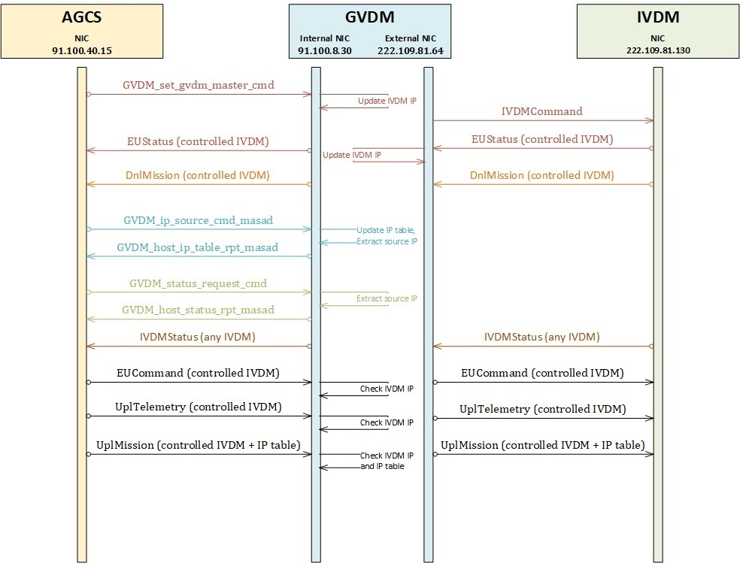

GVDM.exe Metadata

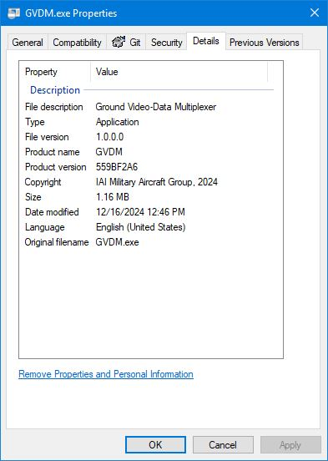

Glossary of Acronyms
Acronym | Description
AGCS | Advanced Ground Control System
CMS | Configuration Management System
COTS | Commercial Off the Shelf
CSC | Computer Software Component
CSCI | Computer Software Configuration Item
DGPS | Differential Global Positioning System
ECR | Engineering Change Request
GVDM | Ground Video-Data Multiplexer
IAI | Israel Aerospace Industries
ICD | Interface Control Document
IVDM | Interface Video-Data Multiplexer
PN | Part Number
UAV | Unmanned Air Vehicle
VDD | Version Description Document

summary
The Ground Video-Data Multiplexer (GVDM) application is a sophisticated, real-time software solution designed to facilitate seamless bidirectional communication between the Ground Control Station (AGCS) and the Interface Video-Data Multiplexer (IVDM). Through its dynamic and intelligent management of message routing configurations, the GVDM ensures efficient and effective data exchange, supporting both commands and feedback mechanisms essential for robust system operations.
The GVDM's multi-threaded architecture, leveraging asynchronous I/O capabilities and advanced message processing techniques, enables high-performance communication across multiple network interfaces. The application’s Boost ASIO and Pcap sniffer integration ensures reliable packet handling. At the same time, the pre-configured logging and diagnostic features provide critical insights into system performance and operational health.
By mapping the application’s individual threads to dedicated CPU physical cores, the GVDM ensures the threads are executed with minimal to no interruptions. This proactive approach to performance management, combined with comprehensive configuration management, guarantees that the application adapts to various operational requirements with minimal manual intervention.
Despite lacking built-in security, redundancy, and failure recovery mechanisms, the GVDM application demonstrates robustness and scalability, supporting communications with up to twenty-four AGCS computers. Its design philosophy prioritizes adaptability and efficiency, making it a reliable choice for managing large-scale operations involving complex data routing needs.
In summary, the GVDM application stands out as a critical component in the communication infrastructure between AGCS and IVDM, providing a scalable, efficient, and intelligent solution for real-time data exchange. Its meticulous design and robust functionality underscore its capability to meet the demanding requirements of modern networked systems.

